Multiple-choice section

|  |  |  |  |  |  |  |  |  |  |
| --- | --- | --- | --- | --- | --- | --- | --- | --- | --- |
| Question | 1 | 2 | 3 | 4 | 5 | 6 | 7 | 8 | 9 |
| Answer | D | C | A | B | C | C | B | D | C |

Question 1 [2.6] [10A]­­

D

10A: mean = 

10B: mean = 

Question 2 [2.3]

**C**

As the maximum temperature reached may not have occurred at one of the times when the measurements were recorded you cannot say with any certainty what that value would have been.

Question 3 [2.5]

**A**

QL = 1.5, median = 3 and QU = 5

Question 4 [2.2]

**B**

The relationship is negative as the points fall from top left to bottom right. They are slightly scattered so we would say a moderately strong negative linear relationship.

Question 5 [2.2]

**C**

All three have two dots far enough from the box to be considered outliers.

Question 6 [2.2]

**C**

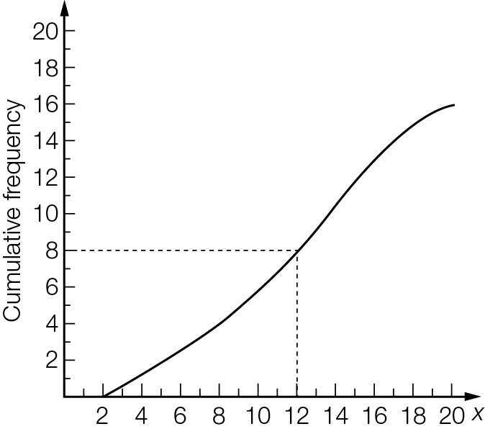

Question 7 [2.1]

**B**

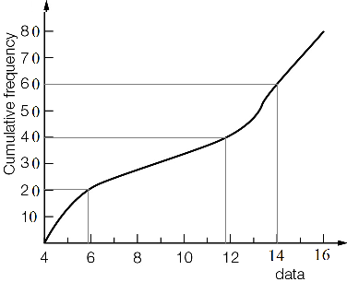

6, 12, 14

Question 8 [2.2]

D

IQR = 37 − 24 = 13 ∴ **A** is correct

24 is the lower quartile ∴ **B** is correct

About 75% of values lie below the upper quartile, which is 37 ∴ **C** is correct

QU + 1.5 × IQR = 37 + 19.5 = 56.5 ∴ 65 is an outlier ∴ **D** is incorrect

Question 9 [2.8] [10A]­­

**C**

Mean ≈ 3.3, standard deviation ≈ 2.87

Multiple-choice total marks: 9

Short answer section

Question 10 2 marks [2.1–2.7]

(a) A cumulative frequency curve can be used to find the five-number summary from a set of continuous data that is presented in grouped form.

(b) An outlier is a value that is significantly lower or higher than the majority of values in a data set.

Question 11 10 marks [2.1]

**(a)** **(i)** 6 8 9 9 10 | 14 14 15 15 20

|  |  |  |  |  |
| --- | --- | --- | --- | --- |
| Lowest | QL | Median | QU | Highest |
| 6 | 9 | 12 | 15 | 20 |

**(ii)** Mean = 

**(b) (i)** QL is the 7th data value.  
The median is the midpoint of the 13th and 14th data value.  
QU is 20th data value.

|  |  |  |  |  |
| --- | --- | --- | --- | --- |
| Lowest | QL | Median | QU | Highest |
| 23 | 23 | 24 | 25 | 27 |

**(ii)**

|  |  |  |  |
| --- | --- | --- | --- |
| x | f | x × f | Cumulative  frequency |
| 23 | 8 | 184 | 8 |
| 24 | 10 | 240 | 18 |
| 25 | 3 | 75 | 21 |
| 26 | 4 | 104 | 25 |
| 27 | 1 | 27 | 26 |
| Total | 26 | 630 |  |

Mean =  ( 1 d.p.)

Question 12 5 marks [2.3]

(a) Set A: (i) median = 3 (ii) range = 6 − 1 = 5 (iii) IQR = 4.5 − 2 = 2.5  
Set B: (i) median = 2 (ii) range = 6 − 0 = 6 (iii) IQR = 4 − 0.5 = 3.5

(b) Set A values are higher on average. Set B data is more spread out than Set A. The highest value is in Set A and the lowest value is in Set B.

Question 13 3 marks [2.2]

**(a)**

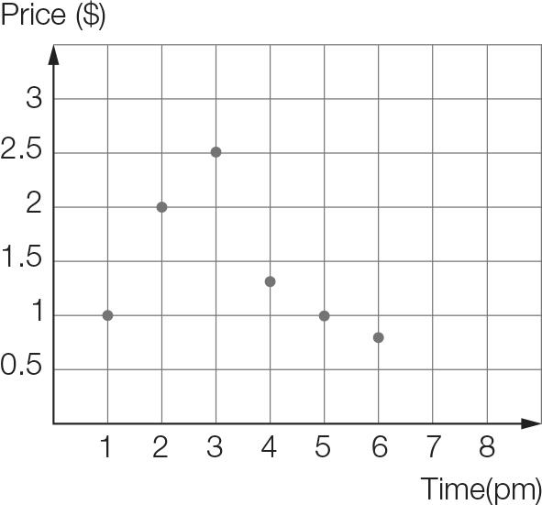

**(b)** At 1 pm the price started at $1 then rose significantly through to 3 pm, where the price had increased by a factor of 2.5. The price then decreased over the next 3 hours, rapidly at first, to slightly below its initial level.

Question 14 10 marks [2.2]

**(a)** Put the data in order as a first step:

1865 1871 1872 1906 1908 1909 1909 1913 1917 1918 1921 1925 1932

1932 1932 1933 1935 1937 1940 1942 1945 1948 1951 1954 1968 1991

lower quartile, QL: 1909

median: 1932

upper quartile, QU: 1942

IQR = 1942 − 1909 = 33 years

**(b)**

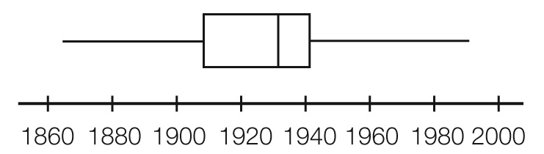

Question 15 5 marks [2.5]

**(a)** The bars are labelled as specific days, spread inconsistently over a 7 year gap. The first bar is given as a month not a day.

**(b)** Between January 2010 and 10 Oct 2015, ticket sales increased from approximately 200 in January 2010 to 2500 on 10 Oct 2015.

**(c)** The earliest set of dates that cover one month are from 10 Oct 2015 to 07 Nov 2015.

**(d)** Total number of ticket sales (from the height of each bar), from 30 April to 03 June 2016:

4500 + 5200 + 5900 + 5400 = 21 000

Divide by the number of concerts.

21 000 ÷ 4 = 5250

Approximately 5250 ticket sales per concert in 2016

Short answer results: ___ / 35

Extended answer section

Question 16 8 marks [2.1]

|  |  |  |  |
| --- | --- | --- | --- |
| Weight (kg) | Frequency | Data  value | Cumulative  frequency |
| <64 | 0 | 64 | 0 |
| 64−<66 | 2 | 66 | 2 |
| 66−<68 | 4 | 68 | 6 |
| 68−<70 | 12 | 70 | 18 |
| 70−<72 | 15 | 72 | 33 |
| 72−<74 | 11 | 74 | 44 |
| 74−<76 | 10 | 76 | 54 |
| 76−<78 | 9 | 78 | 63 |
| 78−<80 | 7 | 80 | 70 |

(a)

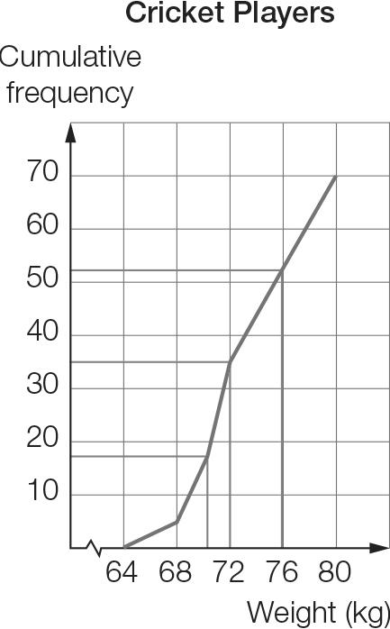

(b)

|  |  |  |  |  |
| --- | --- | --- | --- | --- |
| Min | QL | Median | QU | Max |
| 64 | 70 | 72 | 76 | 80 |

(c) 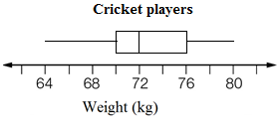

Question 17 5 marks [2.4, 2.6] [10A]

|  |  |  |  |  |  |  |  |  |
| --- | --- | --- | --- | --- | --- | --- | --- | --- |
| English | 45 | 46 | 30 | 34 | 50 | 44 | 38 | 40 |
| Maths | 27 | 50 | 22 | 28 | 44 | 12 | 44 | 42 |

(a) y = 0.68x + 5.80

(b)

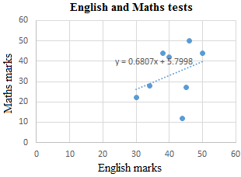

(c) Maths mark = English mark × 0.68 + 5.80

(d) Maths mark = 36 × 0.68 + 5.80 = 30.28  
The predicted mark for Maths is 30.

Question 18 10 marks [2.1, 2.3]

Order the data:

City X: 6.8 7.4 7.5 8.6 9.4 10.4 11.6 12.3 14.3 14.3 15.5 15.7

City Y: 4 5.1 5.9 8.2 9.7 12.5 14.8 17.4 17.9 20.2 20.6 21.2

(a) City X: min = 6.8 °C, QL = 8.05 °C, median = 11 °C, QU = 14.3 °C, max = 15.7 °C  
City Y: min = 4 °C, QL = 7.05 °C, median = 13.65 °C, QU = 19.05 °C, max = 21.2 °C

(b)   
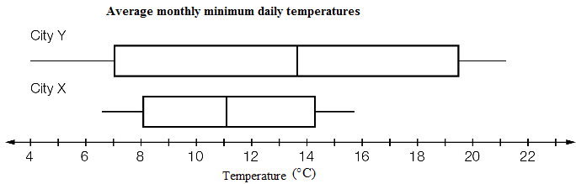

(c) The temperatures for City Y are, on average, higher and more widely spread than for City X.  
City Y has both the lowest temperature and the highest temperature.

Question 19 7 marks [2.1, 2.3]

|  |  |  |  |  |  |  |  |  |  |  |  |  |  |  |  |  |  |  |  |  |  |  |  |  |  |  |  |  |  |  |  |  |  |  |  |  |  |  |  |  |  |  |  |  |  |  |  |  |  |  |  |  |  |  |  |  |  |  |  |  |  |  |  |  |  |  |  |  |  |  |  |  |  |  |  |  |
| --- | --- | --- | --- | --- | --- | --- | --- | --- | --- | --- | --- | --- | --- | --- | --- | --- | --- | --- | --- | --- | --- | --- | --- | --- | --- | --- | --- | --- | --- | --- | --- | --- | --- | --- | --- | --- | --- | --- | --- | --- | --- | --- | --- | --- | --- | --- | --- | --- | --- | --- | --- | --- | --- | --- | --- | --- | --- | --- | --- | --- | --- | --- | --- | --- | --- | --- | --- | --- | --- | --- | --- | --- | --- | --- | --- | --- |
| (a)   |  |  |  | | --- | --- | --- | | x | f | x × f | | 1 | 2 | 2 | | 2 | 3 | 6 | | 3 | 5 | 15 | | 4 | 1 | 4 | | 5 | 2 | 10 | | 6 | 0 | 0 | | 7 | 1 | 7 | | 8 | 2 | 16 | | 9 | 1 | 9 | | 10 | 3 | 30 | | Total | 20 | 99 |   Mean =  = 4.95  On average, the winning teams won 5 games. | (b)   |  |  |  | | --- | --- | --- | | x | f | x × f | | 0 | 15 | 0 | | 1 | 2 | 2 | | 2 | 3 | 6 | | 3 | 5 | 15 | | 4 | 1 | 4 | | 5 | 2 | 10 | | 6 | 0 | 0 | | 7 | 1 | 7 | | 8 | 2 | 16 | | 9 | 1 | 9 | | 10 | 3 | 30 | | Total | 35 | 99 |   Mean =  = 2.828… ≈ 2.8  On average, the teams won 2.8 games. |

Question 20 10 marks [2.3, 2.8]

|  |  |  |  |  |  |  |  |  |  |  |  |  |  |  |  |
| --- | --- | --- | --- | --- | --- | --- | --- | --- | --- | --- | --- | --- | --- | --- | --- |
| (a)   |  |  | | --- | --- | | Weight (kg) | Frequency | | 30–<35 | 2 | | 35–<40 | 7 | | 40–<45 | 9 | | 45–<50 | 12 | | 50–<55 | 7 | | 55–<60 | 3 | |  |

(b) The data in order:  
33 33 37 37 38 38 38 39 39 40 | 40 41 41 42 42 43 43 43 45 45  
45 45 45 45 47 48 48 49 49 49 | 50 51 52 52 52 54 54 55 55 56

|  |  |  |  |  |
| --- | --- | --- | --- | --- |
| Min | QL | Median | QU | Max |
| 33 | 40 | 45 | 49.5 | 56 |

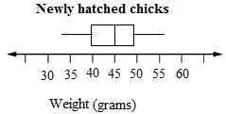

(c) 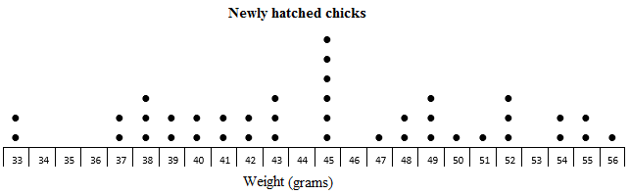

(d) The dot plot has the raw data so you can see exactly how many of each weight. The weights range from 33 g to 56 g with six chicks at 45 g. The histogram shows a symmetrical distribution with a peak in the middle. Weights appear to range from 33 g to 60 g. The box plot shows the weights from 33 g to 56 g with an even spread overall.

[10A] (e) From a calculator (1 d.p.): Mean = 45.0 g, SD = 6.1 g

Extended answer results: ___ / 40

TOTAL test results: ___ / 84